**IMMENSPHERE**

**Minor Project**

**Problem statement:**

Create a classification model to predict whether credit risk is good or bad.

* The above problem is solved using 3 different data Models
* KNN
* Logistic Regression
* SVN

**Source Code:**

import pandas as pd

import numpy as np

import matplotlib.pyplot as plt

import seaborn as sns

from sklearn.model_selection import train_test_split

from sklearn.preprocessing import LabelEncoder

from sklearn.linear_model import LogisticRegression

from sklearn.neighbors import KNeighborsClassifier

from sklearn.svm import SVC

from sklearn.metrics import classification_report, confusion_matrix,accuracy_score

import streamlit as st

df = pd.read_csv('credit_customers (1).csv')

st.header("_Credit_Risk_ :red[Prediction Model]")

st.subheader(':blue[Customer_Credit_Data: ]')

st.dataframe(df.head())

nav = st.sidebar.radio("Select Countplot Feature",["credit_history","savings_status","housing","existing_credits"])

st.subheader(':blue[Based on] '+ nav)

f1 = plt.figure(figsize=(3,3))

sns.countplot(x='class',hue=nav,data=df)

st.pyplot(f1)

# Handling null values

df = df.dropna()

# Handling duplicate records

df = df.drop_duplicates()

# Label Encoding

categorical_cols = ['checking_status', 'credit_history', 'purpose','credit_amount','savings_status','employment', 'existing_credits', 'housing', 'job', 'own_telephone','class']

df1 = df[['checking_status', 'credit_history', 'purpose','credit_amount','savings_status','employment', 'existing_credits', 'housing', 'job', 'own_telephone','class']].copy()

lb = LabelEncoder()

for col in categorical_cols:

df1[col] = lb.fit_transform(df[col])

st.subheader('\n :blue[Data after LabelEncoding: ]')

st.dataframe(df1.head(5))

x = df1.drop('class', axis=1)

y = df1['class']

st.write('Shape of features:\n')

st.write(x.shape,y.shape)

# Split data into training and test data

x_train, x_test, y_train, y_test = train_test_split(x, y, test_size=0.25, random_state=42)

classifier_name = st.sidebar.selectbox('Choose classifier for Prediction',('KNN', 'SVM','Logistic Regression'))

# Parameter Selection

def select_param(clf_name):

params = {}

if clf_name == 'SVM':

C = st.sidebar.slider('C', 0.01, 10.0)

params['C'] = C

ker = st.sidebar.selectbox('Select kernel',('linear','rbf'))

params['kernel'] = ker

elif clf_name == 'KNN':

K = st.sidebar.slider('K', 1, 15)

params['K'] = K

else:

None

return params

params = select_param(classifier_name)

# Classifier Selection

def get_classifier(clf_name, params):

clf = None

if clf_name == 'SVM':

clf = SVC(kernel=params['kernel'],C=params['C'])

elif clf_name == 'KNN':

clf = KNeighborsClassifier(n_neighbors=params['K'])

else:

clf = LogisticRegression(max_iter=10000)

return clf

model = get_classifier(classifier_name, params)

model.fit(x_train,y_train)

y_pred = model.predict(x_test)

acc = accuracy_score(y_test, y_pred)

cm = confusion_matrix(y_test,y_pred)

st.write(f'Classifier = {classifier_name}')

st.write(f'Accuracy =', acc)

st.write(cm)

st.write(f'Classification Report\n',classification_report(y_test,y_pred))

**Output:**

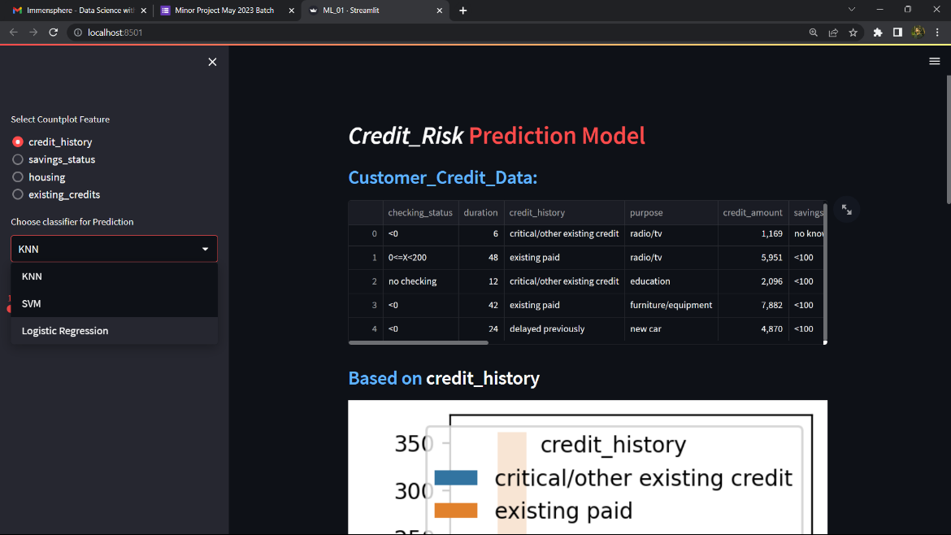

**SUBMITTED BY:**

**SHIVAM SONI**

**shivam.soni@ptuniv.edu.in**